MA 323 (2020) Monte Carlo Simulation Lab 11

**Name:** Udandarao Sai Sandeep

**Roll Number:** 180123063

**Dept.:** Mathematics and Computing

**Q1.**

To calculate the discrepancy, function **‘func()’** was implemented**.** It takes in **N** as the input variable. The value of **n** has been set to **10000** for all cases. In each case, the [0,1] closed interval was divided into N equal intervals, and the number of xi’sin each case was counted for each interval. **Vol(A)** is equal to 1/N. This is because the lebesgue measure of a closed interval is equal to the length of the interval. The **discrepancy** was calculated by taking the maxmimum of **abs** ( cnt(A)/n – vol(A) ) for all sub-intervals, where **cnt(A)** represents the number of xi’s lying in A and **vol(A)** represents the lebesgue measure of A. The ouput obtained is as follows:

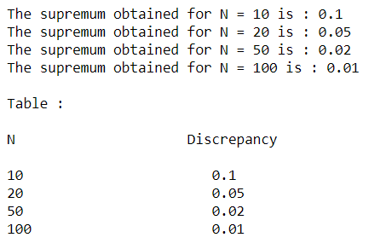

**Ouptut in Tabulated form:**

|  |  |
| --- | --- |
| N | Discrepancy |
| 10 | **0.1** |
| 20 | **0.05** |
| 50 | **0.02** |
| 100 | **0.01** |

With increase in the value of N, the discrepancy value decreases.